AWS Backup

1). Project Title
Automated Disaster Recovery Snapshot Management using AWS Backup

2). Objective
The objective of this POC is to implement automated backup and snapshot management for AWS resources using AWS Backup service. The solution ensures periodic backups, centralized backup management, retention control, and disaster recovery readiness.

3). Business Requirement
Organizations require automated and reliable backup mechanisms to:
- Protect critical workloads
- Reduce data loss risks
- Support disaster recovery
- Meet compliance requirements
- Eliminate manual backup operations
This POC demonstrates automated snapshot creation and retention using AWS native services.

4). Solution Overview
AWS Backup service automatically creates backups for EC2 and RDS resources based on assigned resource tags.
AWS Backup service is used to automate backups for EC2 and RDS resources based on resource tags. Backup plans define the backup schedule, retention policy, and lifecycle management.
The solution performs:
- Scheduled backups
- Snapshot retention management
- Automated recovery point creation
- Centralized backup monitoring

5). Schedule backup for EC2 &RDS via AWS Backup
Through AWS backup service will take backup for the resources EC2 & RDS based on the tags. The backup will run only with the tags. We need to create backup plan for EC2 & RDS, Once creates the backup plan, we have the options called Add backup rule and Resource assignments
- Add Backup rule: Defines frequency of backup (Daily, Weekly, Monthly) based the requirement
- Resource assignments: Defines which resource planned for backup (EC2 or RDS)
Please refer the below screen shots how to add tags and how to enable backup for the EC2 and RDS.

5.1 How to add tag to instance: -
Once login to the Aws console select instance goto tags click on manage tag and add new tag then click on save button.
Steps
- Login to AWS Management Console
- Navigate to EC2 Dashboard
- Select the target EC2 instance
- Open the Tags tab
- Click Manage Tags
- Add the required backup tag
Save the configuration
Please find the below snippet for the reference:
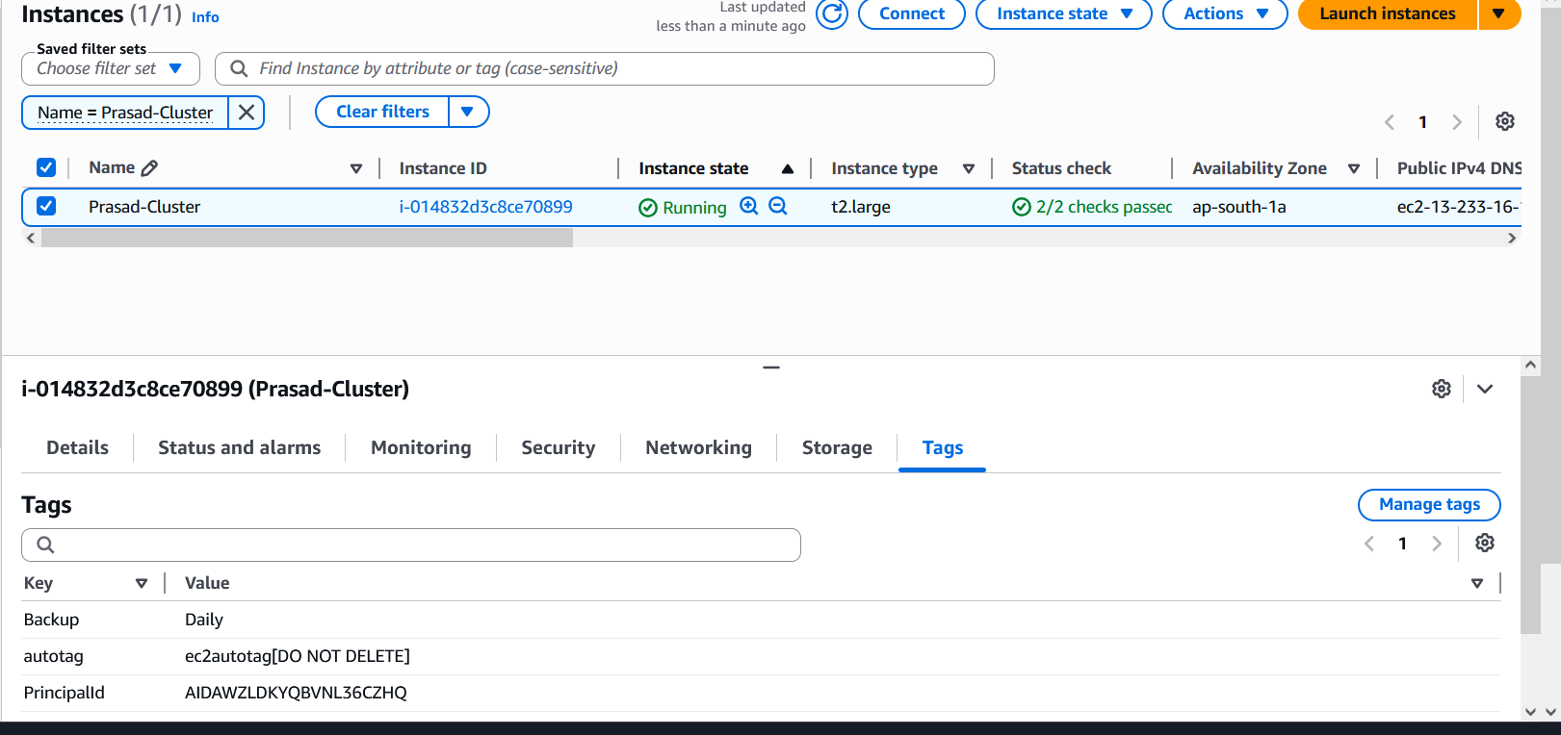

5.2 Creating backup plan using JSON file through AWS backup service:
Backup Plans define:
- Backup frequency
- Backup windows
- Backup retention periods
- Lifecycle management
- Target backup vault

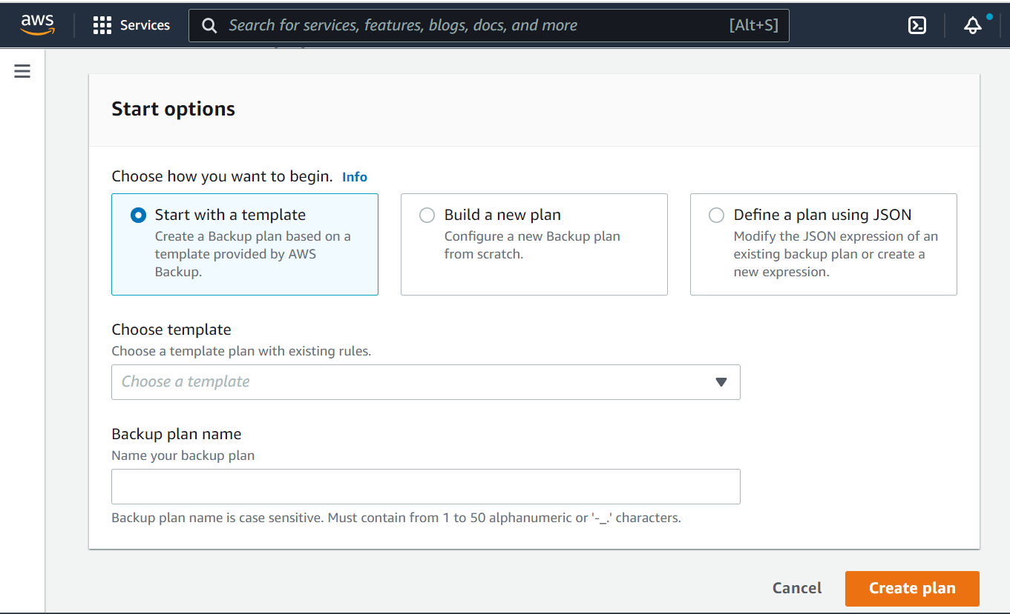

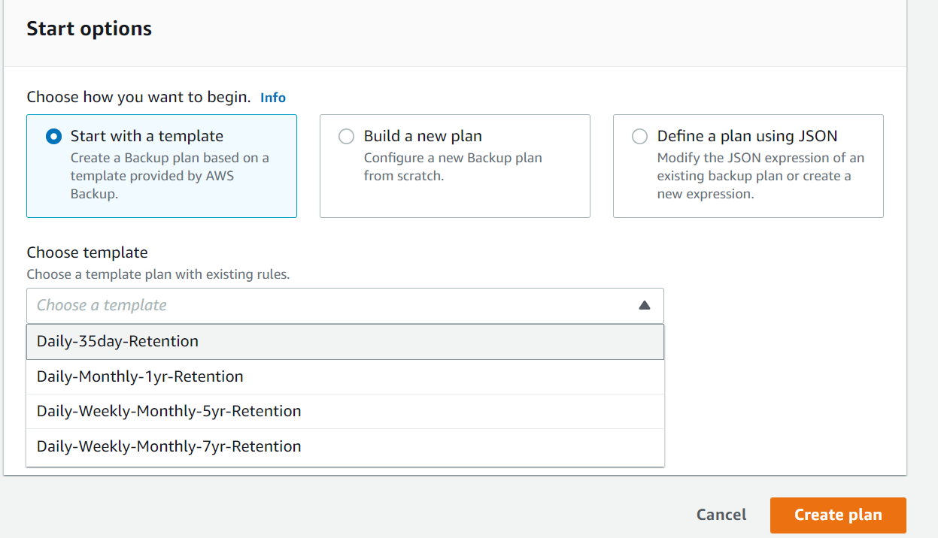
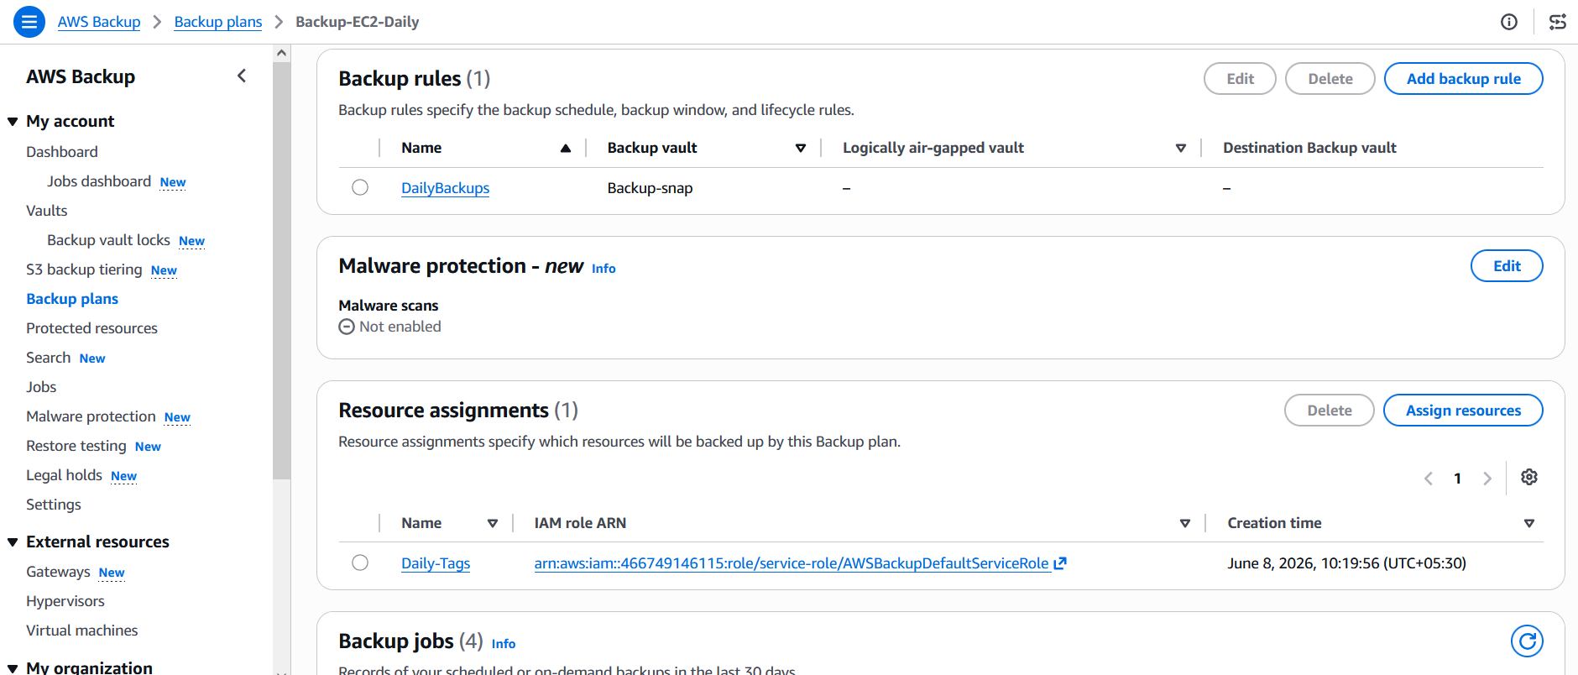
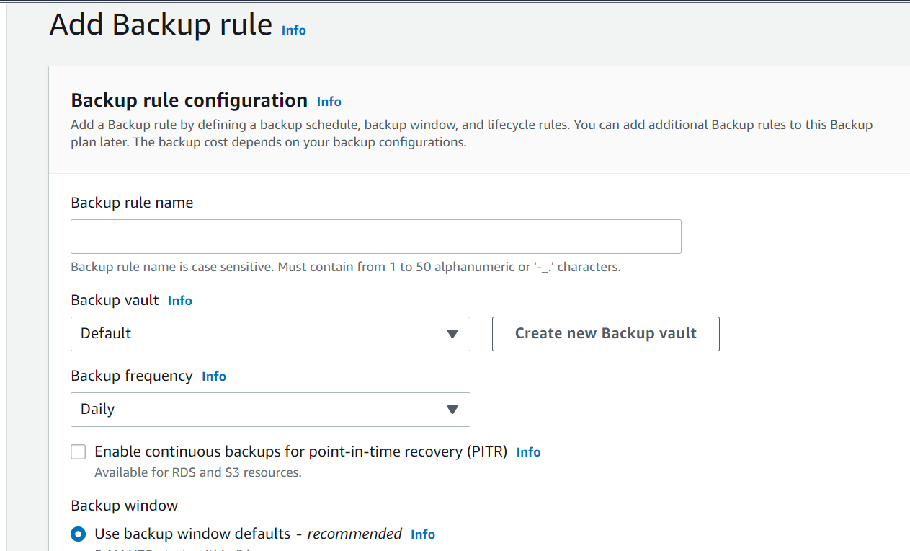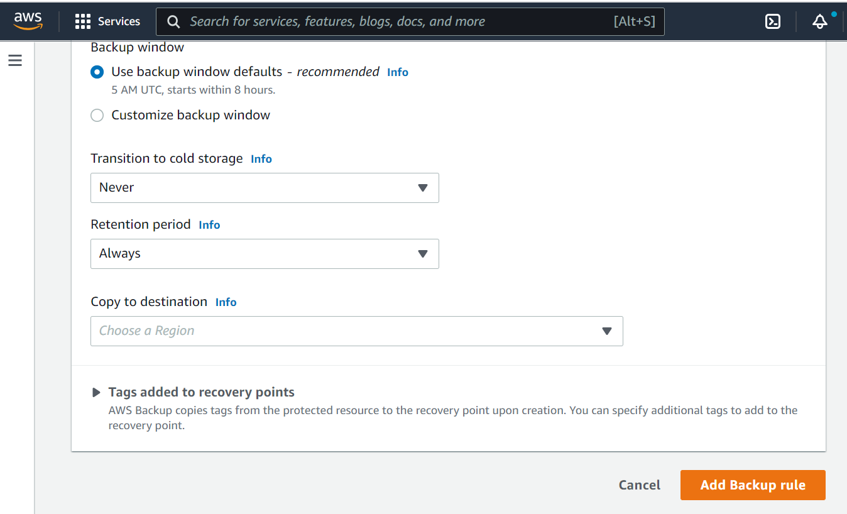
5.3 Please find the relevant RDS backup plan snippets attached/below: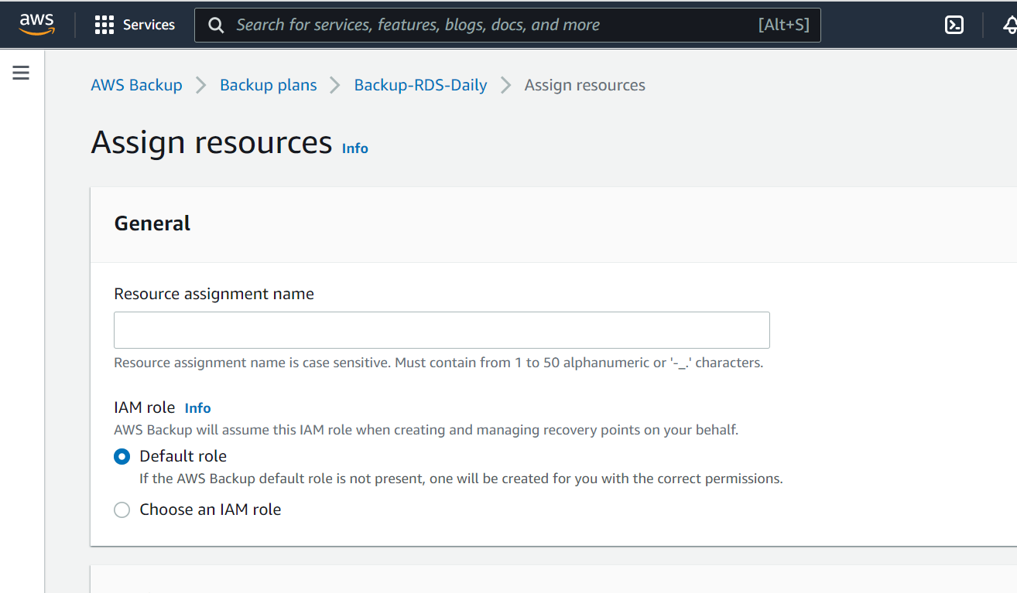
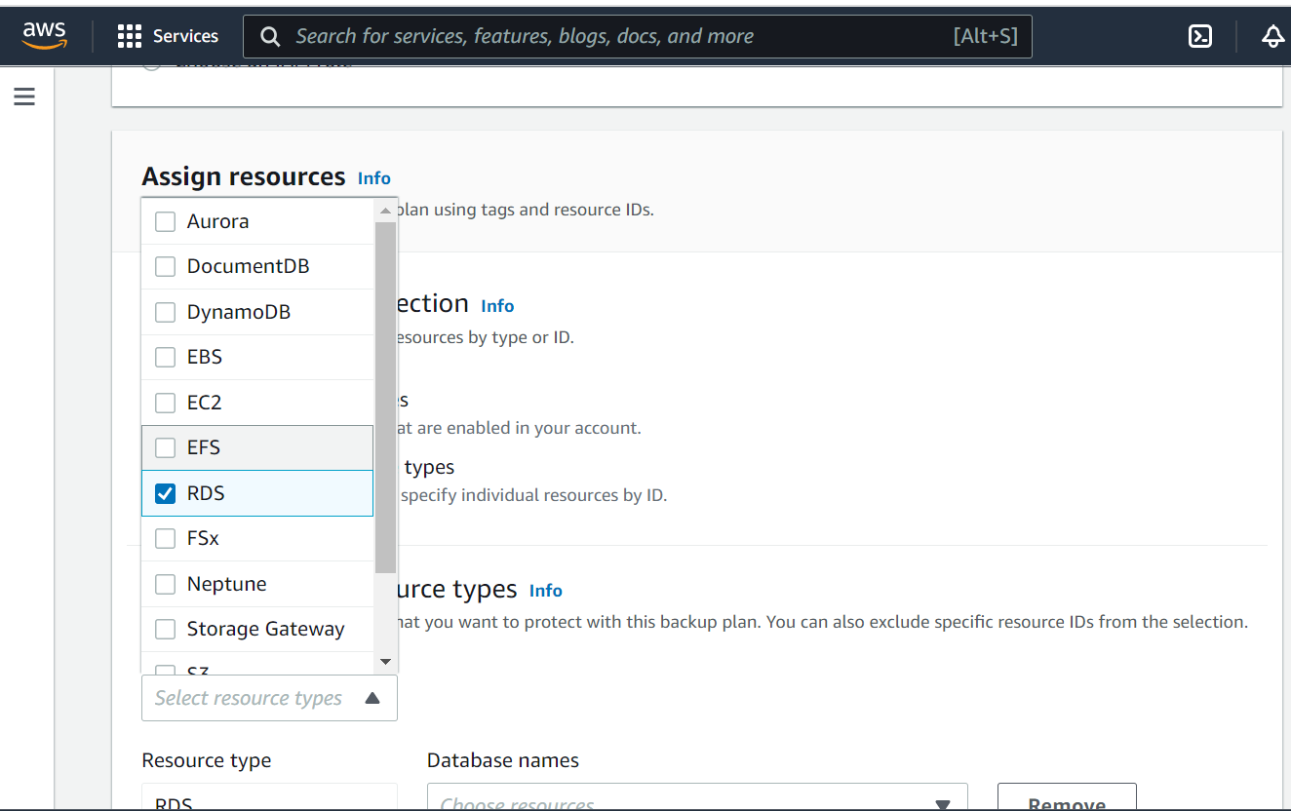
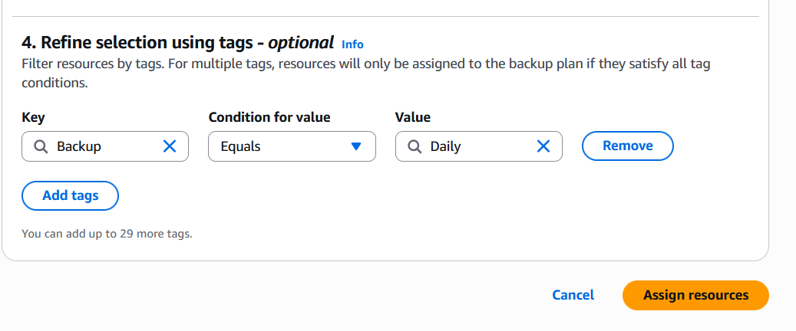
5.4 Please find the relevant EC2 backup plan snippets attached/below: 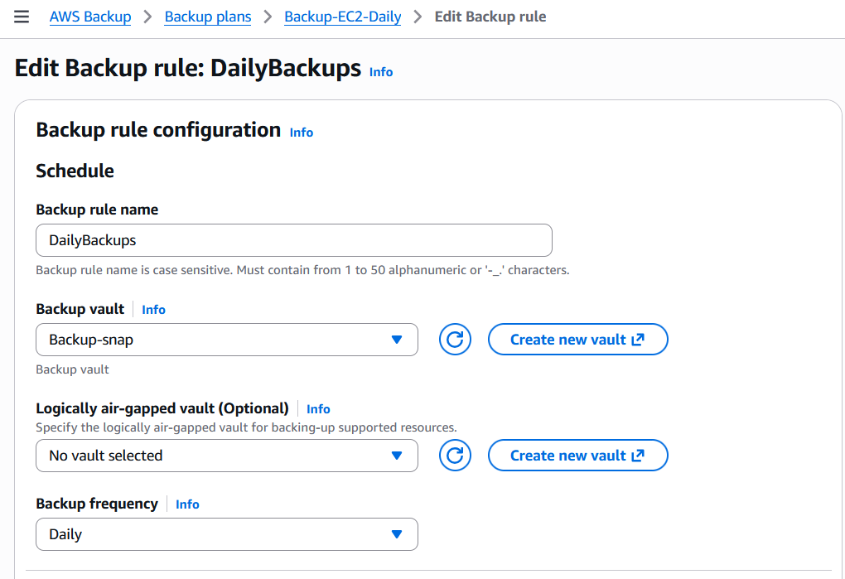 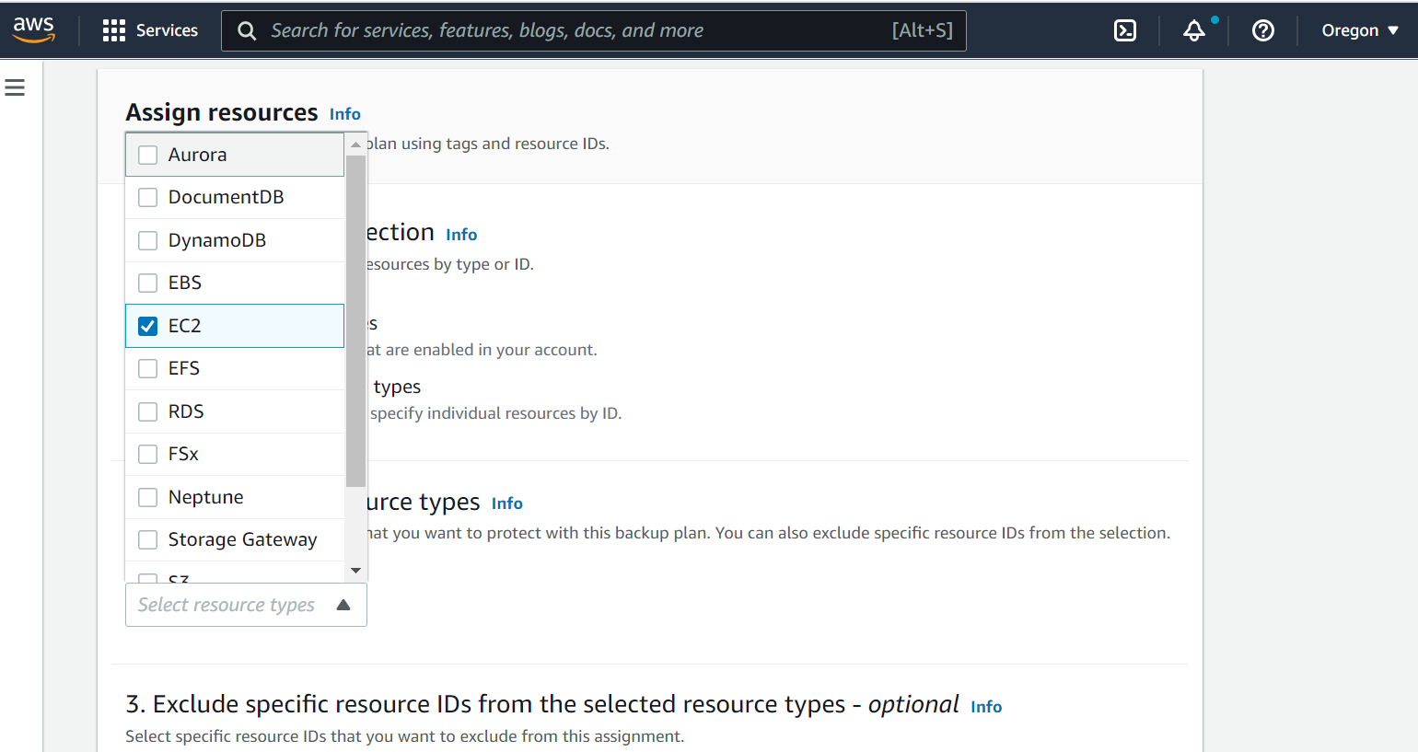

6). Customize backup frequency and retention policy in AWS backup for EC2 and RDS

Enabling incremental backup for the AWS services EC2 and RDS via AWS Backup solution as per the frequency and manage the backup data as per the retention policy.
Backup Frequency: - Daily, weekly, monthly
Backup retention period (in days): - 7days, 28days, 35 days.
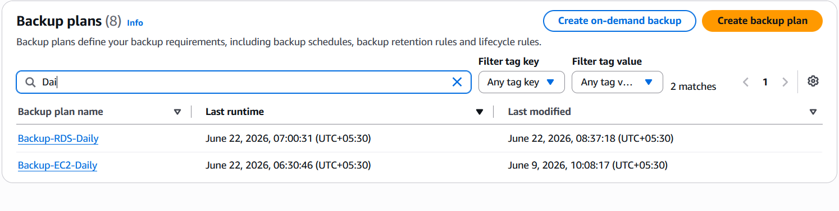
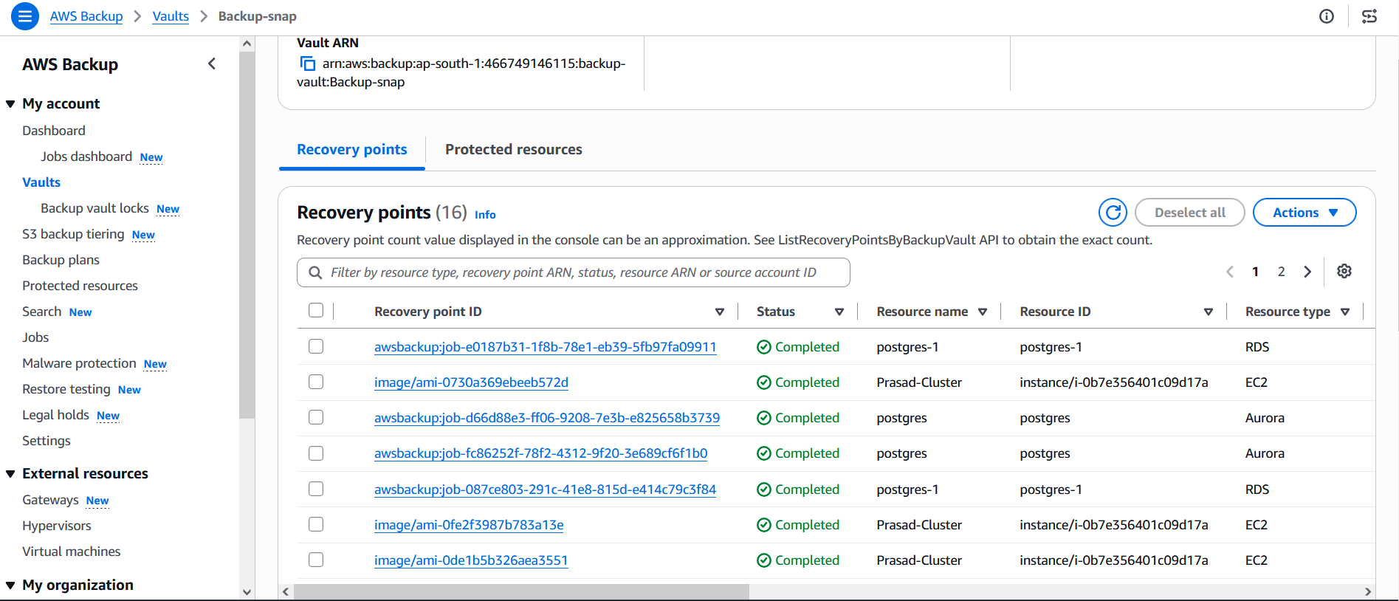

7). Benefits of AWS Backup: -
Operational Benefits
- Centralized backup management
- Reduced administrative effort
- Automated scheduling
- Standardized backup processes
Business Benefits
- Improved disaster recovery readiness
- Reduced risk of data loss
- Compliance support
- Enhanced business continuity
Technical Benefits
- Incremental backups
- Recovery point management
- Tag-based automation
- Secure backup storage

8). AWS Services Supported by AWS Backup: -
AWS Backup provides centralized backup management for the following AWS services:
Service | Backup Supported
Amazon EC2 (EBS-backed instances) | Yes
Amazon EBS | Yes
Amazon RDS | Yes
Amazon Aurora | Yes
Amazon DynamoDB | Yes
Amazon EFS | Yes
Amazon FSx for Windows File Server | Yes
Amazon FSx for Lustre | Yes
Amazon FSx for NetApp ONTAP | Yes
Amazon FSx for OpenZFS | Yes
Amazon S3 | Yes
AWS Storage Gateway | Yes
Amazon Neptune | Yes
Amazon DocumentDB | Yes
VMware Workloads (AWS Backup Gateway) | Yes

9). Disaster Recovery and Restore Process: -
In the event of data loss or system failure:
- Navigate to AWS Backup Console
- Select the Recovery Point
- Choose Restore
- Specify restore configuration
- Launch restored resource
- Validate application functionality
This process significantly reduces Recovery Time Objective (RTO) and Recovery Point Objective (RPO).

9.1 Recovery Time Estimate for Restore:
Scope: Restoration of 100 GB Amazon EC2 Instance and 100 GB Amazon RDS Database.

9.2 Scenario A: Same-Region Restoration (Primary DR Protocol)
- Target Recovery Window: 15 to 35 minutes total
- Breakdown:
  - Amazon EC2: 5 to 10 minutes (Infrastructure provisioning and OS initialization).
  - Amazon RDS: 15 to 25 minutes (Database cluster provisioning and storage attachment).
  - Validation & Health Checks: 5 minutes.
Note: Both resources are restored in parallel, so the overall timeline is governed by the longer RDS task.

9.3 Scenario B: Cross-Region Restoration (Geographic Failover)
- Condition 1: If backups are already replicated to the target region:
  - Target Recovery Window: 25 to 45 minutes total
  - Reasoning: Infrastructure spin-up takes the same time as the primary region, plus a small buffer to manually map target-region subnets, security groups, and parameters.
- Condition 2: If backups must be copied on demand first:
  - Target Recovery Window: 1 to 2 hours total
  - Reasoning: Requires a data transfer window across the AWS backbone network (approx. 30–60 minutes for 100 GB), followed by the standard infrastructure spin-up time.

10). Conclusion:
This POC successfully demonstrates the implementation of AWS Backup as a centralized and automated backup solution for AWS resources.
The current implementation protects Amazon EC2 and Amazon RDS workloads using tag-based backup policies, scheduled backup plans, and retention management. The same architecture can be easily extended to additional AWS services such as Amazon S3, DynamoDB, EFS, FSx, Aurora, Neptune, and DocumentDB.
By adopting AWS Backup, organizations can strengthen disaster recovery capabilities, improve operational efficiency, ensure compliance, and establish a scalable enterprise backup strategy across their AWS environment.
*****************************************

AWS Backup Implementation Using AWS CLI

This guide demonstrates how to configure AWS Backup for EC2 and RDS resources using AWS CLI, including Backup Vault creation, Backup Plans, Tag-Based Resource Assignment, Backup Monitoring, and Restore Operations.

Prerequisites
Before starting, ensure:
1.AWS CLI Installed
Verify installation:
Command: aws --version
Expected output:
aws-cli/2.x.x Python/3.x

2. Configure AWS Credentials
Command: aws configure
Provide below deatials:
AWS Access Key ID
AWS Secret Access Key
Default Region (ap-south-1)
Default Output Format (json)
Verify:
Command: aws sts get-caller-identity

3. Required IAM Permissions
The user/role must have permissions for:
- AWS Backup
- EC2
- RDS
- IAM
- KMS (if encryption is used)
Minimum policies:
- AWSBackupFullAccess
- AmazonEC2FullAccess
- AmazonRDSFullAccess
Step 1: Create Backup Vault
A Backup Vault stores recovery points created by AWS Backup.
aws backup create-backup-vault \
--backup-vault-name Prod-Backup-Vault
Verify Vault
aws backup list-backup-vaults
Expected:
{
"BackupVaultList": [
{
"BackupVaultName": "Backup-snap"
}
]
}

Step 2: Verify AWS Backup Service Role:
Check if the default role exists:
aws iam get-role \
--role-name AWSBackupDefaultServiceRole
If not present create manually.:
Open IAM Console → Role → Create Role
Role ARN Example:
arn:aws:iam::466749146115:role/service-role/AWSBackupDefaultServiceRole
Save this ARN.

Step 3: Tag EC2 Instance
List EC2 instances:
Command: aws ec2 describe-instances
output:
i-014832d3c8ce70899
Add backup tag:
aws ec2 create-tags \
--resources i-014832d3c8ce70899 \
--tags Key=Backup,Value= Daily
Verify:
aws ec2 describe-tags \
--filters Name=i-014832d3c8ce70899,Values=i-014832d3c8ce70899

Step 4: Tag RDS Instance
Find RDS ARN:
aws rds describe-db-instances
Example:
arn:aws:rds:ap-south-1:466749146115:cluster:postgres
Add tag:
aws rds add-tags-to-resource \
--resource-name arn:aws:rds:ap-south-1:466749146115:cluster:postgres
--tags Key=Backup,Value=Daily
Verify:
aws rds list-tags-for-resource \
--resource-name arn:aws:rds:ap-south-1:466749146115:cluster:postgres

Step 5: Create Backup Plan :
Command: vi backup-plan.json
Please paste the below plan and save it.

{
"BackupPlanName": "EC2-RDS-Daily-Backup-Plan",
"Rules": [
{
"RuleName": "DailyBackups",
"TargetBackupVaultName": "Backup-Snap",
"ScheduleExpression": "cron(0 0 * * ? *)",
"StartWindowMinutes": 60,
"CompletionWindowMinutes": 120,
"Lifecycle": {
"DeleteAfterDays": 35
}
}
]
}

For Create plan run the below command:
aws backup create-backup-plan \ --backup-plan file://backup-plan.json
Output:
{
"BackupPlanId": " b9b894d5-0dd8-4038-a67e-f78293e386c6"
}
Save the BackupPlanId.

Step 6: Create Resource Assignment
Create:
backup-selection.json
Replace:
with actual values.

{
"BackupSelection": {
"SelectionName": "EC2-RDS-Selection",
"IamRoleArn": "arn:aws:iam:: 466749146115: role/service-role/AWSBackupDefaultServiceRole",
"ListOfTags": [
{
"ConditionType": "STRINGEQUALS",
"ConditionKey": "Backup",
"ConditionValue": "Yes"
}
]
}
}
Create assignment:
aws backup create-backup-selection \
--backup-plan-id b9b894d5-0dd8-4038-a67e-f78293e386c6 \
--backup-selection file://backup-selection.json

Step 7: Verify Backup Plan
Command: aws backup list-backup-plans
Output:
aws backup get-backup-plan \
--backup-plan-id b9b894d5-0dd8-4038-a67e-f78293e386c6

Step 8: Start Backup Immediately (On-Demand)
Find EC2 Volume ARN:
aws ec2 describe-volumes
Example ARN:
arn:aws:ec2:ap-south-1: 466749146115:volume/vol-05293509cfd390892
Start backup:
aws backup start-backup-job \
--backup-vault-name Backup-snap \
--resource-arn arn:aws:ec2:ap-south-1:123456789012:volume/vol-123456789 \
--iam-role-arn arn:aws:iam:: 466749146115: role/service-role/AWSBackupDefaultServiceRole
Output:
{
"BackupJobId": " b9b894d5-0dd8-4038-a67e-f78293e386c6 "
}

Step 9: Monitor Backup Jobs
List jobs:
Command : aws backup list-backup-jobs
Check specific job:
Command : aws backup describe-backup-job \ --backup-job-id b9b894d5-0dd8-4038-a67e-
f78293e386c6
Possible statuses:
CREATED
PENDING
RUNNING
COMPLETED

Step 10: View Recovery Points
Command : aws backup list-recovery-points-by-backup-vault \
--backup-vault-name Backup-snap
Output includes:
RecoveryPointArn
CreationDate
ResourceArn
Status

Step 11: Delete Backup Plan (Cleanup)
List plans:
Command : aws backup list-backup-plans
Delete:
Command : aws backup delete-backup-plan \
--backup-plan-id b9b894d5-0dd8-4038-a67e-f78293e386c6

Step 12 : Useful AWS Backup CLI Commands
List Vaults
aws backup list-backup-vaults
List Backup Plans
aws backup list-backup-plans
List Backup Jobs
aws backup list-backup-jobs
List Restore Jobs
aws backup list-restore-jobs
List Recovery Points
aws backup list-recovery-points-by-backup-vault \
--backup-vault-name Backup-snap
Get Backup Plan Details
aws backup get-backup-plan \
--backup-plan-id b9b894d5-0dd8-4038-a67e-f78293e386c6
***********************************

